**HSS roll composition characteristics**

1. **Carbon (C)**

Compared with ordinary rolls, high-speed steel rolls have a high carbon content, usually W(C) = 1.5% ~ 2.8%, to ensure that a sufficient amount of high-hardness and high-thermal stability carbides are generated with strong carbide-forming elements, such as MC, M2C, M6C, M7C3, etc., and to ensure that a strong martensitic matrix is obtained to improve the red hardness and wear resistance of the roll. However, the products of carbon and other elements are more numerous and complex in composition. If the carbon content is too low, the number of carbides generated is small. During quenching and heating, the martensite hardness is insufficient, and the secondary hardening effect is poor during the subsequent tempering process, which will reduce the hardness and wear resistance of the roll. If the carbon content is too high, exceeding the required ratio corresponding to the carbide-forming elements, a large amount of network eutectic carbides will be generated at the grain boundaries, reducing the plasticity and fracture toughness of the high-speed steel; and, too high a carbon content will increase the amount of residual austenite after quenching of the high-speed steel, increase the number of tempering times, increase energy consumption, increase costs, and easily induce casting cracks, resulting in a reduction in the comprehensive mechanical properties of the high-speed steel roll. Therefore, the carbon content in the high-speed steel roll should maintain a "balanced carbon" ratio with the strong carbide-forming elements.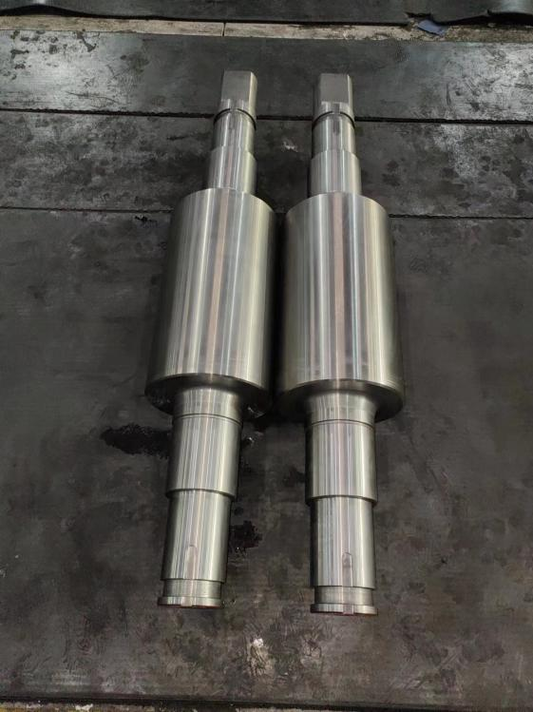

1. **Tungsten (W)**

Tungsten is the preferred element to improve the tempering resistance and red hardness of high-speed steel. Tungsten mainly exists in the form of W2C (M2C type) and Fe3W3C, Fe4W2C (M6C type) in high-speed steel, which can improve the wear resistance of the roll. During high-temperature quenching, part of the M6C dissolves into austenite to improve the hardenability of high-speed steel; the other part of undissolved M6C can effectively prevent the growth of austenite grains at high temperatures to improve wear resistance. During high-temperature tempering, M2C disperses and precipitates, producing a secondary hardening effect, which significantly improves the thermal hardness, hardness and wear resistance of high-speed steel rolls. Adding an appropriate amount of tungsten element can improve the distribution of carbides, but the tungsten content is too high.

During the solidification process, the excess tungsten is discharged into the remaining liquid phase, exacerbating the eutectic reaction, generating a large amount of M2C at the grain boundaries, and reducing the quality of high-speed steel. plasticity and fracture toughness. If the tungsten content is insufficient, less M2C will be generated, which will affect the roll hardness.

Comprehensive consideration, the tungsten element content in high-speed steel rolls should be less than 5%.

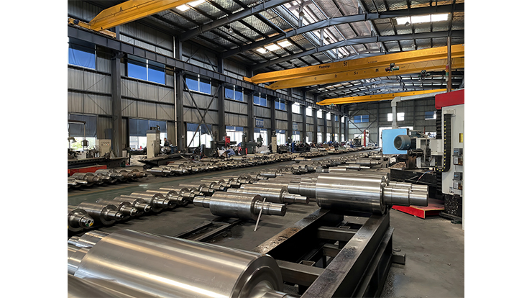

1. **Molybdenum (Mo)**

The effect of molybdenum is similar to that of tungsten, and both can improve the red hardness of high-speed steel. Molybdenum also forms M6C carbides, which have the same lattice type as tungsten, and the lattice parameters are almost the same, but the density is lower. Tungsten and molybdenum are usually converted into tungsten equivalents.

The higher the tungsten equivalent, the better the wear resistance; the lower the tungsten equivalent, the better the toughness. The effect of molybdenum on the performance of high-speed steel rolls is also different from that of tungsten: the density of molybdenum is lower than that of tungsten, which can eliminate segregation to a certain extent; during tempering, dispersion hardening occurs, which will reduce the toughness of high-speed steel, but molybdenum can prevent carbides from precipitating along grain boundaries and improve the toughness of high-speed steel. If tungsten is completely replaced by molybdenum, the following problems will occur: during tempering, the temperature at which carbides precipitate from martensite in molybdenum-containing high-speed steel is lower than that in tungsten-containing high-speed steel, so

the thermal stability decreases; during heat treatment, molybdenum-containing high-speed steel has a serious tendency to decarburize; and molybdenum-containing high-speed steel has coarser grains than tungsten-containing high-speed steel. Therefore, tungsten and molybdenum are usually mixed and added. The content of tungstenshould be controlled at 3.0% to 6.5%.

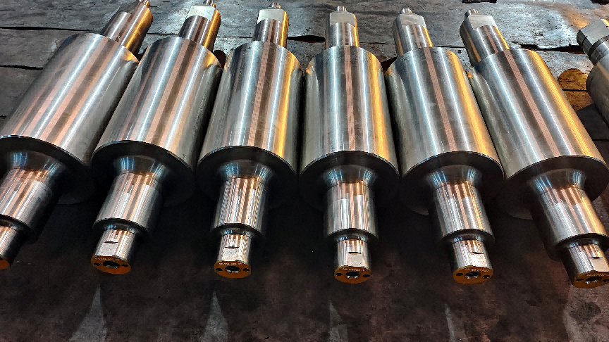

1. **Chromium (Cr)**

The main function of chromium in high-speed steel rolls is to enhance the hardenability of steel and have a secondary hardening effect. It can improve the hardness and wear resistance of high-carbon steel without making the steel brittle. Chromium and carbon form Cr23C6 type carbides, which are almost completely dissolved in austenite during quenching and heating, increasing the stability of supercooled austenite and greatly improving the hardenability of steel. Chromium can also adjust the carbon balance of the matrix and improve the steel's oxidation resistance, decarburization and corrosion resistance.

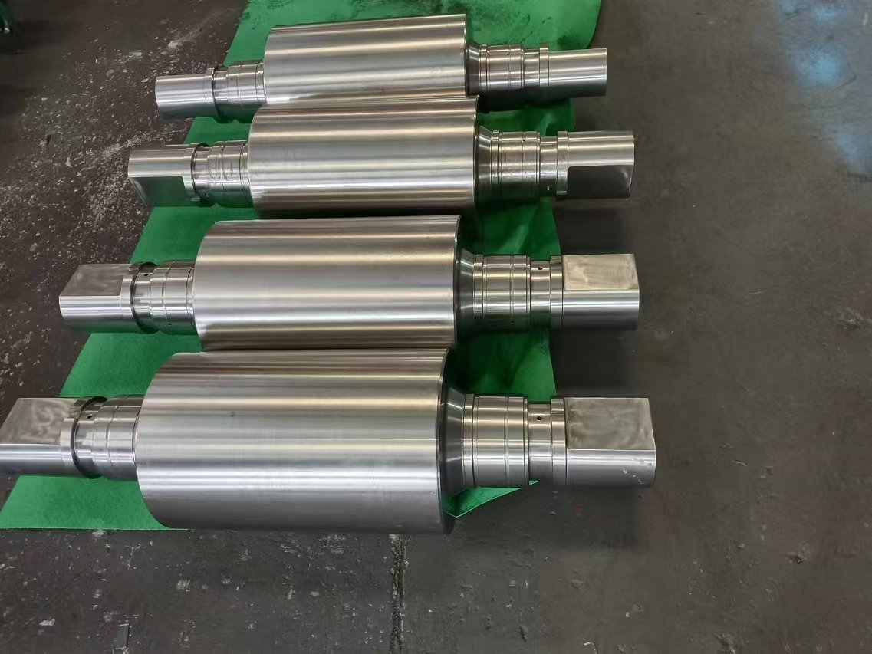However, when other components remain unchanged, the increase in chromium content, the increase in eutectic carbides, and the increase in fine chromium-rich carbides in the matrix have little effect on the primary carbide composition. However, excessive chromium content will form unstable carbides during tempering, reducing thermal stability and red hardness. Usually, the chromium content in high-speed steel rolls is between 4% and 9%.

1. **Vanadium (V)**

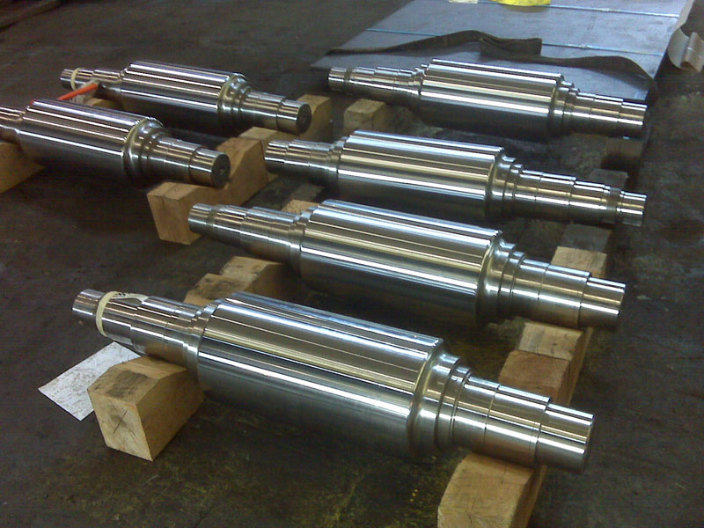Vanadium is a strong carbide-forming element, mainly used to improve the hardness and wear resistance of steel. Vanadium can form carbides VC (or V4C3), which are very stable, extremely difficult to dissolve, have high hardness (much higher than the hardness of W2C), and have fine particles and uniform distribution, so it plays a great role in improving the hardness and wear resistance of steel. During tempering, VC is dispersed in the matrix in a spherical or nearly spherical shape, which can improve the impact toughness, hardness and wear resistance of high-speed steel. However, when the vanadium content is too high, a relatively coarse primary VC will first precipitate in the liquid phase. The VC density is small, and it is easy to segregate inward during centrifugal casting, weakening the effect of the vanadium element. Therefore, considering the influence of the vanadium element, the vanadium content in high-speed steel is controlled at 2.5% to 6%.

1. **Niobium (Nb)**

The role of niobium element is similar to that of vanadium element, but niobium element has a stronger ability to form carbides than vanadium element, forming carbide NbC which is coarser than VC. Since the carbides of niobium are coarse, the niobium content in high-speed steel should be controlled. However, the combined effect of niobium and vanadium can increase MC and decrease M7C3 produced during tempering, making the secondary hardening effect more significant. Usually the niobium content in high-speed steel rolls is 0 to 2%.

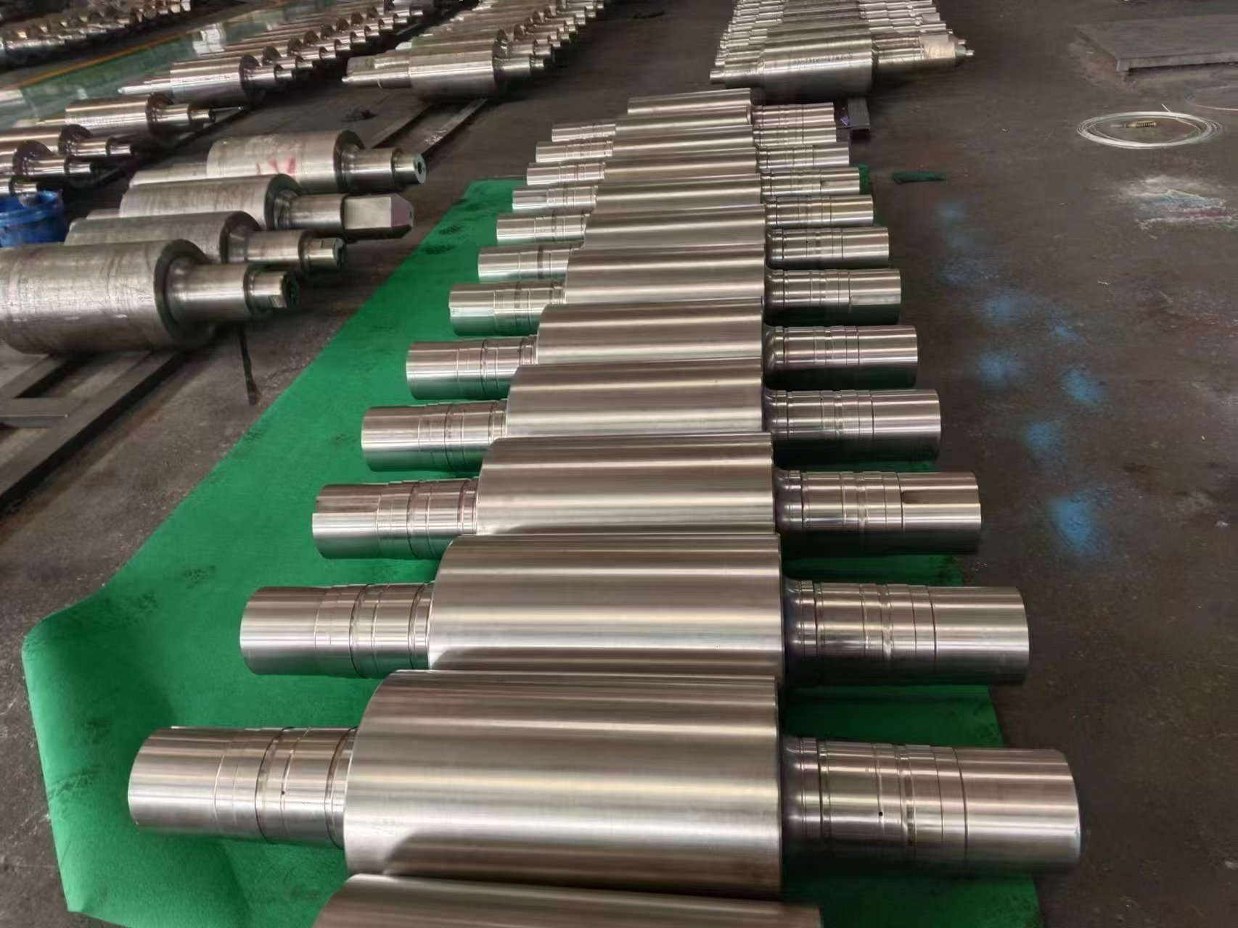 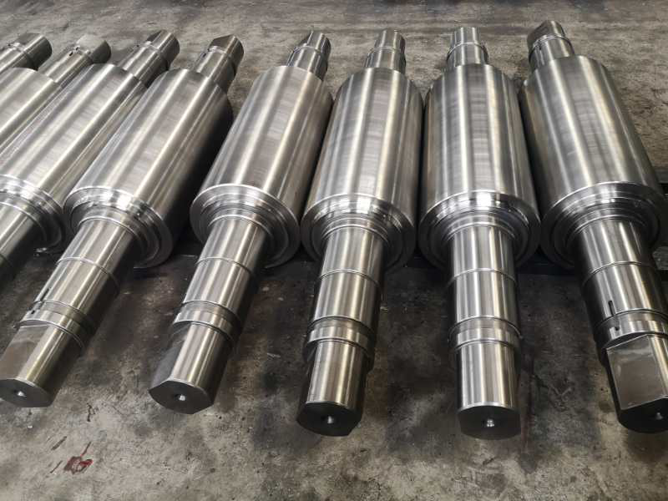

1. **Nickel (Ni)**

Nickel can improve the mechanical properties of high-speed steel, especially the plasticity and toughness of high-speed steel. When the matrix is ​​martensite, it has little effect on the strength of high-speed steel rolls, and adding an appropriate amount of nickel can improve the roll's anti-cracking and anti-stripping properties. However, nickel will increase the amount of residual austenite in high-speed steel, resulting in a decrease in the hardness and red hardness of high-speed steel. Considering the impact of nickel on the performance of high-speed steel rolls, the nickel content is generally controlled within the range of 0.5% to 1%.

1. **Silicon (Si)**

Silicon is a non-carbide-forming element. It can promote the decomposition of carbides M2C in high-speed steel that are unfavorable to performance into M6C and MC when reheated, refine the carbides, and improve the toughness of high-speed steel. Silicon also has a certain deoxidation effect. However, when silicon dissolves in the martensite matrix, it will increase the brittleness of the matrix, and excessive silicon content will cause the roll working layer to crack and peel easily. Therefore, the silicon content in high-speed steel rolls should be controlled within 0.2% to 1.0%.

1. **Aluminum (A1)**

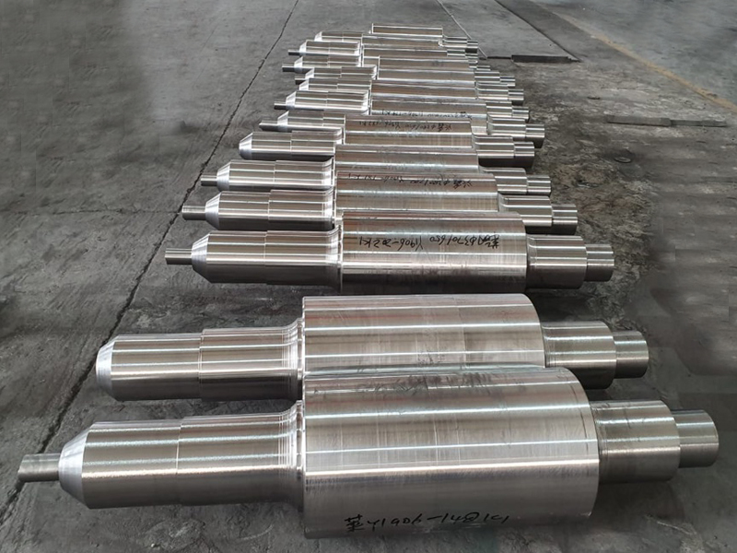Aluminum has a similar effect to silicon. Aluminum is dissolved in the matrix, which can refine the grains and improve the tempering stability, hardness and red hardness of high-speed steel. Aluminum can also reduce the decomposition temperature of coarse columnar M2C carbides, which is beneficial to improving the toughness of high-speed steel rolls. However, aluminum increases the decarburization sensitivity of high-speed steel, and when the aluminum content exceeds 2%, the quenching hardness of high-speed steel will drop sharply.

Therefore, the aluminum content in high-speed steel rolls should be controlled within the range of 0.1% to 0.6%.

1. **Manganese (Mn)**

Manganese can improve the strength, hardness and wear resistance of high-speed steel within a low content range, and can reduce the martensitic transformation temperature and critical cooling rate as the manganese content increases, thereby improving the hard nability of high-speed steel. However, an increase in manganese content will lead to an increase in the amount of retained austenite, reducing the thermal stability and hardness of high-speed steel. Usually, the manganese content in high-speed steel rolls is 0.3% to 1.0%.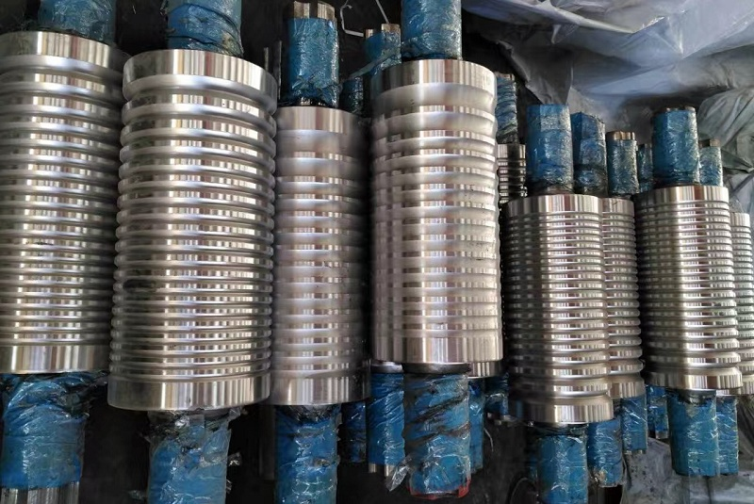

1. **Cobalt (Co)**

Cobalt itself does not form carbides. The principle of cobalt improving the hardness and red hardness of high-speed steel is different from that of tungsten, molybdenum, vanadium and niobium. Most of cobalt in high-speed steel is dissolved in the matrix, and only a small part is dissolved in carbides, which can improve the wear resistance of high-speed steel, as shown in Figure 1. During tempering, it increases the nucleation rate of precipitated MC and M:C, slowing down their aggregation and growth rate. In addition, cobalt can increase the melting temperature of the grain boundary of high-speed steel, thereby increasing the quenching temperature of steel and increasing the alloy degree in austenite. These effects effectively improve the heat resistance of high-speed steel.

However, when the cobalt content is too high, it will also reduce the toughness of high-speed steel and increase the tendency of decarburization. Comprehensively considering, the cobalt content in high-speed steel rolls should be 1% to 4%.

1. **Sulfur and phosphorus (S, P)**

Trace impurities of sulfur and phosphorus are brought in by the raw materials and are both harmful elements. Sulfur and phosphorus generally accumulate at the grain boundary in the form of low-melting point inclusions, causing cracks during the cold and hot cycle of the roll, reducing the strength and plasticity of the roll. Therefore, the sulfur and phosphorus content in high-speed steel rolls should be strictly controlled below 0.03%.